Lambda function to manage RDS instances for update and user access windows

Pre-requisites:  
Tags required:

* State: Up or Down (Patch is handled by Lambda)
* Started (Set by admin allocating user access window): In standard format
* Stopped (Set by admin allocating user access window): In standard format

RDS Instance Modifications (To make these changes, updates to the Event Triggers will be required):

* Maintenance window Start and End range (set up as required)
* Maintenance window Duration (set up as required)

AWS Lambda Functions [x2]:

* Script to Spin Up instances for weekly (monthly) update
* Script to Take Down instances

CloudWatch Events (Lambda triggers) [x2 or x3 – depending on requirement]:

* Trigger for Spin Up function
* Trigger for Take Down function:
  + Trigger for Take Down function for Patch tag
  + Trigger for Take Down function for Up tag
* (Optional) In case of differing Maintenance window – Another Event Trigger can be set up for either of the above Take Down Triggers to accommodate trigger difference

Drawback: More than necessary Lambda triggering – unnecessary cost

Initial Setup:

1. Set the correct tags:

* State:
  + If instance is Running, set to Up (or equivalent)
  + If instance is Stopped, set to Down (or equivalent)
* Started: Set this according to the required user access window
* Stopped: Set this according to the required user access window

1. Modify RDS Instance maintenance window: In accordance to the day of the week (or month) that is ideal for patching to initialize. This is Closely linked to Event Trigger
2. Set Event Triggers for Lambda Functions:

* Spin Up: Set this for the same day and 1.5 hours before maintenance window (Start range), to allow sufficient time for natural spin up (View further implementations)
* Take Down - In this case it is set up so it checks for each case (Up or Patch) at the same time of the day:
  + Patch tag: Set this to trigger function .5 hours after maintenance window (End range), to allow any possible delays
  + Up tag: Set to trigger at a specific time every morning

Scenario:

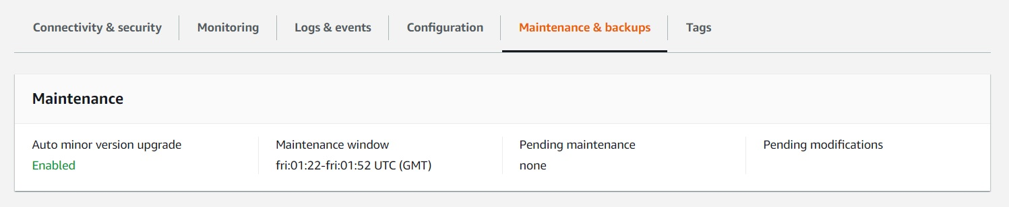

*Maintenance window set to Friday at 01:22 – Friday at 01:52*

*A 30 minute maintenance window [default]*

*Weekly maintenance [default]*

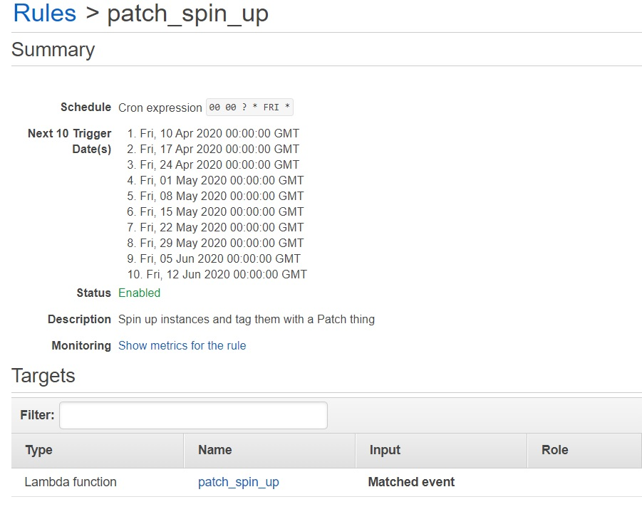

*The CloudWatch Event Trigger for the Spin Up Lambda function should be roughly 1 hr to 1.5 hrs in advance to allow for natural spin up time*

*Set to Friday at 00:00 [to go with the weekly maintenance window model]*

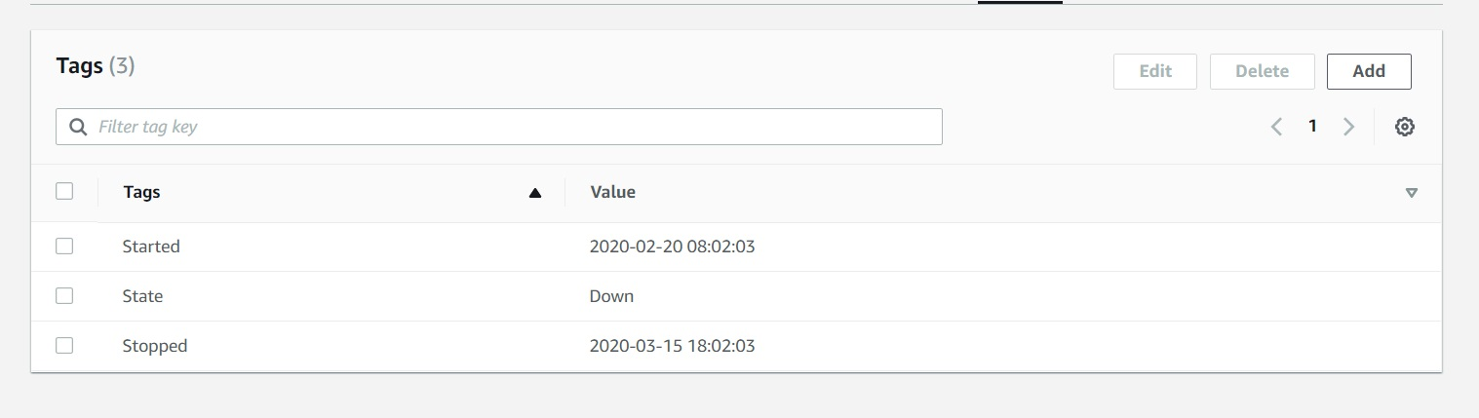

*Instances in State: Down will be checked:*

* *If Instance maintenance window is the same day of the week as today AND the maintenance window start value is higher than current time – Evaluate as True*
* *If instance fails any of the checks – Evaluate as False*

If Evaluated to True:

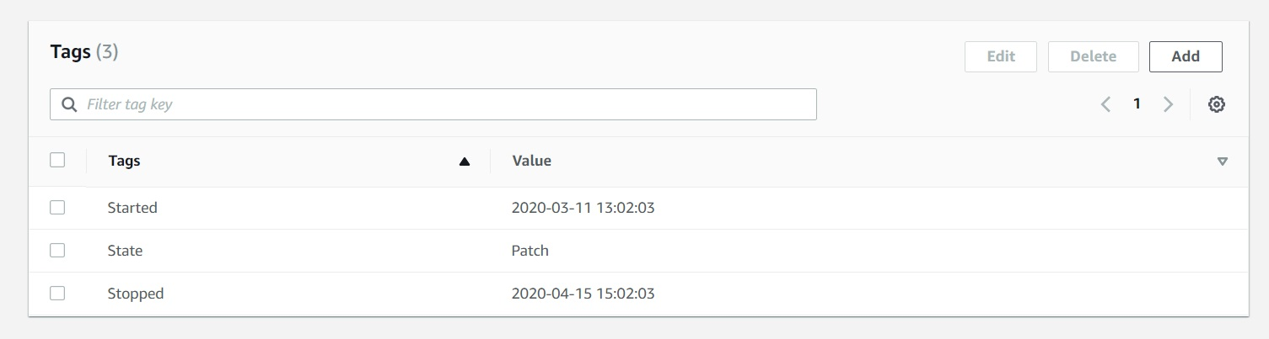

***Start the instance and change State tag to Patch***

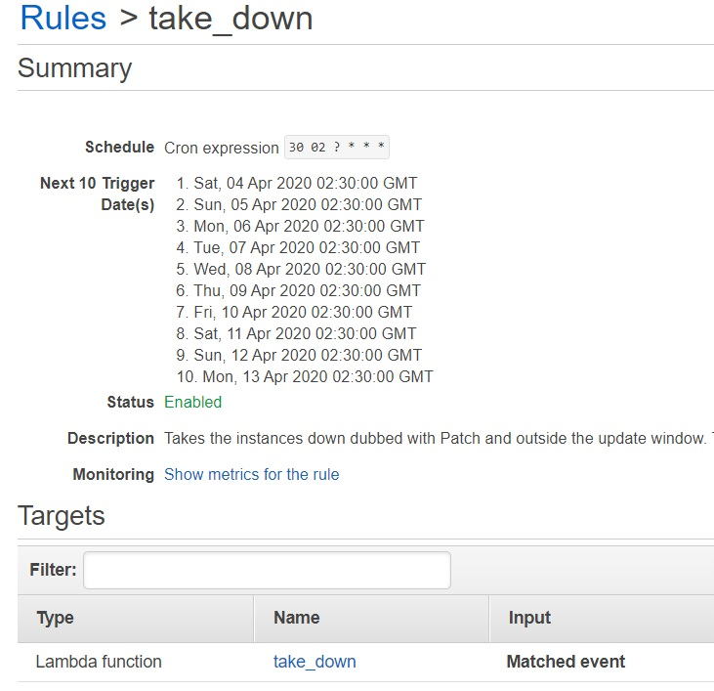

*The CloudWatch Event Trigger for the Take Down Lambda function needs to be roughly .5 hrs after the maintenance is scheduled to complete*

*Set to Every day at 02:30*

*Instances in State: Up and State: Patch will be checked:*

* *If State: Patch AND the maintenance window end value is lower than current time:*

***Stop instance***

* *If State: Up – Evaluate as True*

*If Evaluate as True:*

* *Check if instance is in the Started – Stopped date range*
  + *If outside the range specified*

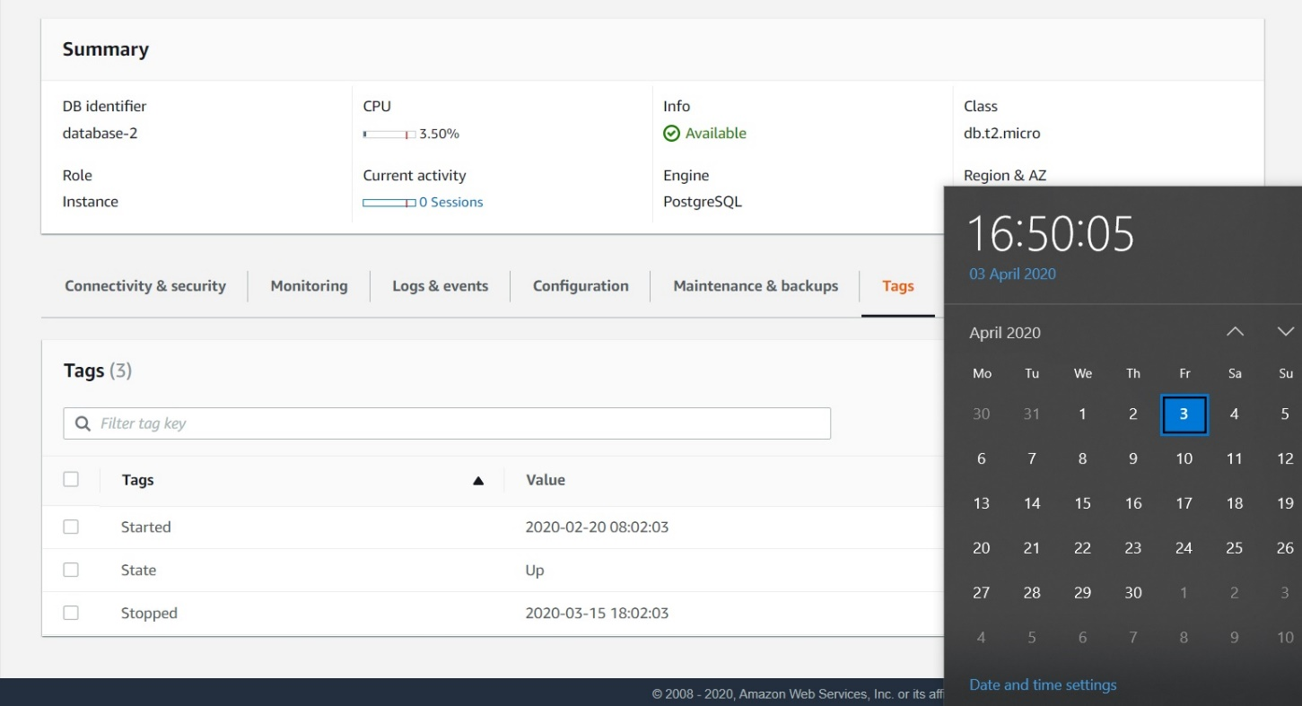

***The instance will be stopped and tagged as State: Down***

* + *If inside the range specified*

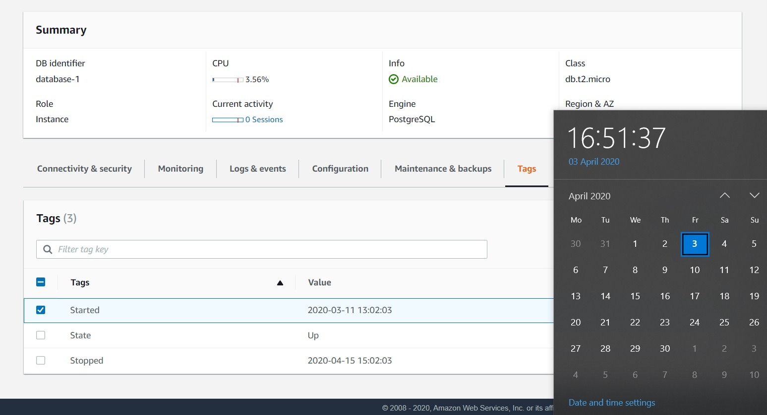

***The instance will be left as is***